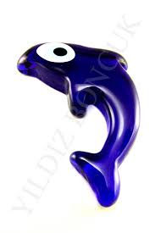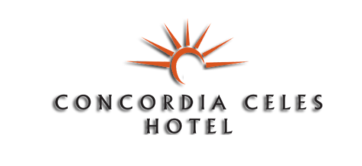 HOTEL FACT SHEET 2022
- GENERAL INFORMATION :

HOTEL NAME : CONCORDIA CELES HOTEL
REGION : ALARA TOURISM CENTER
CATEGORY : FIVE STARS HOTEL (LOCAL CATAGORY)
ADRESS : OKURCALAR / ALANYA / ANTALYA
TELEPHONE : 00 90 . 242 . 527 50 05 PBX
FAKS : 00 90 . 242 . 527 50 06
WEB PAGE : www.concordiaceles.com

E – MAIL : info@concordiaceles.com

- TRANSPORTATIN TO/FROM HOTEL:
TO DISTANCE METHOD DURATION
ANTALYA CITY CENTER. 105. km Bus 100 min.

ANTALYA AIRPORT 90. km Bus 90 min
ALANYA 35. km Shuttle bus 30 min.
SİDE 30. km Shuttle bus 25 min.

- ACCOMMODATION:

TOTAL ROOMS : 401 ROOMS ARE WITH :
TOTAL BEDS : 1000 Direct Telephone
Music broadcast from TV
Standart rooms : 353( 24 m² ) (1 french + 1 twin bed) TV (satellite)
Junior Suit : 19 (35 m² ) (1french + 1 twin bed) Mini bar (SOFT DRINKS)
Family rooms : 25 (45 m² ) (2 bed rooms, one bath-wc) Air-condition, Balcony, Hair Dryer, Safe, Bath & Shower
Handicapped rooms : 4 ( 24 m² ) (1 french)
4.SPECIAL FEATURES :

Site Surface : 16.000 m²
Main Building : 5.600 m²
Outdoor Pool : 450 m² Children Pool: 36 m²
Indoor Pool : 80 m² Children Pool: 6 m²
Restaurant : 1.000 m² / outdoor 200 person – Indoor 800 person OPENING TIMES
A’la carte Restaurant : 285 m² / 250 person 19:00 / 21:00
Pool Bar : / 200 person 10:00 / 23:00
Snack– Beach Bar : 285 m² / 250 person 10:00 / 17:00
Lobby Bar : / 120 person 10:00 / 24:00
Disco : 250 m² / 120 person 00:00 / 02:00
Game Hall : Billiard, Table tennis, Backgammon, Shah-mat and cart games
Health center : Turkish Bath, Sauna, Massage (extra)
Children Park : Playing are for the children between 03-12age
Mini club : Children for between 03-12age.
Shopping center : Jewellery, Market, Coiffeur, Boutique, Leader shop, Souvenier shop, Photographer.
Meeting Hall : 300 person
Cleaning service : Daily cleaning the rooms and towels are changing in every 2 days.
5.SPORT AND LOCAL FACILITIES :

With an extra charge Free of charge Ultra All inclusıve consept
* Tennis (with light) * Football (mini) (day time) * Breakfast 07:00 –10:00
* Billiard * Basketball (day time) * Late Breakfast 10:00 –10:30
* wind Surf * Volleyball (day time) * Lunch 12:30 –14:30
* Pedal Boat * Beach Volley (day time) * Snack 11:00 – 16:00
* Canoe * Tennis (day time) * Gozleme 11:00 – 16:00
* Banana * Table Tennis *Burger World 11:00–16:00
* Water Sky * Dart * Patisserie 11:00 –17:00
* Parasailing * Fitness * Dinner 19:00 –21:00
* internet and video games * Wi-Fi (lobby) * Soup time 23:00 –24:00 *Ice-cream (01.06-30.09) 14:00-17:00
6. GUEST SERVICE :

With an extra charge Free of charge Bars

Doctor (everyday 2 hour in hotel) Baggage Service * Lobby Bar 10:00 – 23:00
Jeep, car, bike, motorbike rental Wake up service *Restaurant Bar 12:30 – 21:00
Massage and Beatty center Private Beach * Pool Bar 10:00 – 23:00
From / to Airport Transportation Chaice Longue * Snack Bar 10:00 – 17:00
Laundry Service Mattress and Umbrellas at the Beach and Pool * Disco Bar 24:00 – 02:00 (All Drinks FREE)
Safe Money exchange
Telephone and Fax Animation Shows
Massage and Beatty center Turkish Bath and Sauna
Turkish Coffee-Fresh fruit juices Beach Towel (change 1 euro)
7.USEFULL INFORMATION

*** Use full Credit Cards : Visa, master card, maestro kart, Euro kart
*** Language : Turkish is the official language. German, English and Russian are spoken language..
*** PETS ARE NOT ALLOWED.

