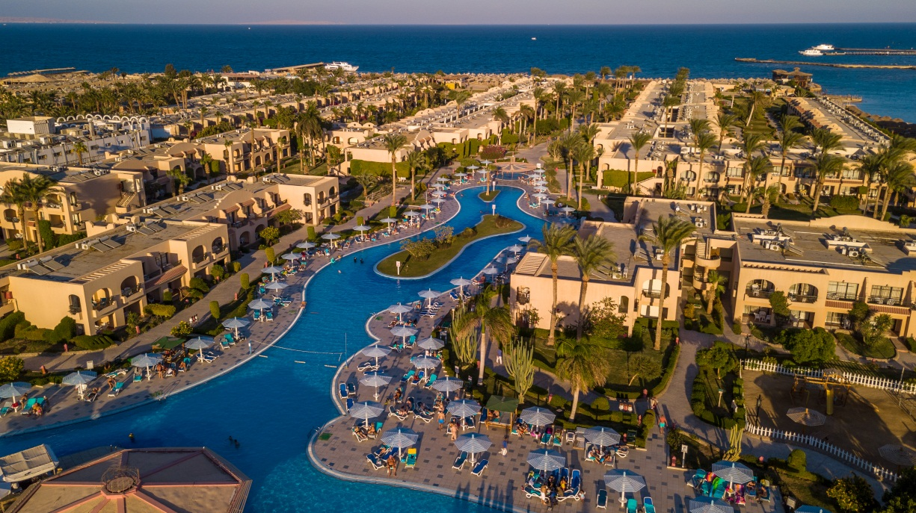

Hotel Fact Sheet

Ali Baba Palace is a unique 4* family-friendly resort, situated in the heart of Hurghada 77,322 M. The city that warms your heart with its beautiful sandy beaches 116 M, turquoise waters, and yearlong sunshine. Hurghada’ International Airport is a hub to several different airlines that travel directly to European cities and elsewhere, the city’s location on the map makes it an accessible year long getaway for many families, couples, individuals who enjoy diving, sailing or laying on sunny beaches. Hurghada is the place for everyone and Ali Baba make it happen by offering a bit of everything.
General
Address: | Km 17, Hurghada, Safaga Rd., Villages rd., Hurghada Beside Aladdin Hurghada Beach Resort. Hurghada Red Sea, Egypt
Category:  General Manager:  Operation Manager  Front office Manager  Guest relation:  Sales Department: | 4 stars  Mr.Mohamed Shaban , E-mail: alibaba.gm@hwaidakhotels.com  Mr. Mohamed Abdallah E-mail: operational.excellence@hwaidakhotels.com  Mr. Ahmed Heshmatd E-mail: alibaba.frontoffice@hwaidakhotels.com  alibaba.guestrelation@hwaidakhotels.com  Mr. Mohamed Gad  : asst.dosm@hwaidakhotels.com
Reservation:  Phone: | reservation.alibaba@hwaidakhotels.com  +2 065 3 460 463/73
Fax: | +2 065 3 460 472
Website: | www.hwaidakhotels.com
Date of inauguration: | November 2000
Open: | All year round
Languages: | English, German, Russian, Multilingual staff at the reception and guest relation desk and animation team.
Type of catering: | All inclusive

Rooms
Number of rooms: total 755

Double Room:

98 rooms with garden and pool view, (15 sea view side) about 33-35 sq. m, Maximum 2 Adults +2 Children occupancy. With: twin or king size beds, bathtub or shower, WC, air condition, direct Telephone, sat. TV, mini-fridge, hair dryer and balcony or terrace.

Double Room Deluxe:

467 rooms Deluxe with garden and pool view, about 33-35 sq. m, Maximum 2 Adults +2 Children occupancy. With: twin or king size beds, shower, WC, air condition, direct Telephone, sat. TV, mini-fridge, hair dryer, safe and balcony or terrace.

Triple Room:

10 Rooms with garden view, about 33-35 sq. m, 3 adult’s occupancy. With: 3 singles beds, bathtub or shower, WC, air condition, direct telephone, sat. TV, mini-fridge, hair dryer and balcony or terrace
Family Room Connected Deluxe:
130 (65*2 Bed Rooms) Rooms Deluxe equipped just like a dbl and a connecting door between each two rooms, one with king size bed and the other with twin beds, about 33-35 sq. m each room, maximum 4 adults plus 2 children or 2 adult plus 2,3 or 4 children or 3 adults plus 2,3 children occupancy. With: 2 showers, WC, air condition, telephone, sat. TV, mini-fridge, hair dryer, safe and balcony or terrace.
Bunk Bed Room:
33 rooms about 33-35 sq. m, maximum 3 adults or 2 adult plus 2,3 children occupancy.
With: king size bed and bunk bed, bathtub or shower, WC, air condition, direct Telephone, sat. TV, mini-fridge, hair dryer and balcony or terrace.

Family suits with 2 bed rooms and one main entrance:

2 family rooms about 70 sq. m, separate bedrooms, maximum 4 adults or 2 adults plus 2, 3 children.
With: king size bed and twin beds, bathtub or shower, WC, air condition, direct Telephone, sat. TV, mini-fridge, hair dryer and balcony or terrace.

Family Suits with 2 bed rooms and one main entrance deluxe:

21 family rooms about 70 sq. m, separate bedrooms, maximum 4 adults or 2 adults plus 2, 3 children.
With: king size bed and twin beds, bathtub or shower, WC, air condition, direct Telephone, sat. TV, mini-fridge, hair dryer and balcony or terrace.

Junior Suite:

4 Junior suite about 42-45 sq. m each, one bedroom, maximum 4 adults or 2 adults plus 2 children. With: king size bed, 1 bathtub or shower, WC, air condition, direct Telephone, sat. TV, mini-fridge, hair dryer and balcony or terrace.

Disabled Room Deluxe:

7 rooms Deluxe on the ground floor especial designed to meet the requirements and comfort of disabled people about 33-35 sq. m, maximum 2 adults or 1 adult plus 1, 3 children occupancy.

Disabled Room connected Deluxe:

4 Family Connected (2 Bed Rooms one of them is Prepared for Disabled) rooms Deluxe equipped just like 2 dbl and a connecting door between each two rooms, one with king size bed and the other with twin beds, about 33-35 sq. m each room, maximum 4 adults plus 2 children or 2 adult plus 2, 3 or 4 children or 3 adults plus 2, 3 children occupancy. With: 2 showers, WC, air condition, telephone, sat. TV, mini-fridge, hair dryer, safe and terrace.
Wi-Fi available for free in the lobby and the room
Laundry service available for all guests (extra charge).
Restaurants:
Ali Baba has 4 restaurants inside its lobby, offering a wide range of cuisines from around the world that are carefully selected by our international high-skilled Chefs.
Restaurant’s Names:

- Main Restaurant: “Ringo Tree” – recently renovated serving international cuisine
- Italian Restaurant: “Bella Italia” - recently renovated
- Oriental Restaurant: “Zomorodah”
- A la carte restaurant: “Shogun” serving Indian, Chinese, Sushi menu

Bars:
- Beach Bar Restaurant : “Laguna” – serving drink, snack’s during lunch time & evening dinner sea food and oriental food free of charge ( pre reservation )
- Lobby Bar (all inclusive – drinks )
- Pool Bar (all inclusive – drinks, snack’s, ice cream, donuts , dinner )
- 40 Thieves Disco all inclusive – drinks until 23:00
- Aqua Park bar: all inclusive non-alcoholic drinks, snack’s
- Moorish café ( Shisha ) ( drinks extra charge )
- Vitamin Bar Daily fresh juices ( extra charge )

”All Inclusive” includes a wide selection of national drinks like soft drinks, beer, coffee, tea and house wine ( serve by the cups ).

Aqua Park:
- Toddlers Aqua Park (children must be accompanied by parents) - heated
- Teenagers & Adults Aqua Park (age, weight & height restrictive) - heated

Warning guests: with heart conditions, pregnant or with back problem should refrain from using the Aqua Park.
The multi-language entertainment team: also plays a great role at keeping our guests, healthy, active and fit during their holidays by offering them; Aqua Gym, Zumba, Belly Dance etc… With a wide variety of activities and entertainment facilities, enjoy our daily live shows and daily live music.
At Ali Baba Palace our entertainment team organizes international holiday events such as: Halloween Party ( 31 October), Christmas Eve (24-25 December), New Year’s Eve (31 December), Coptic Christmas (06 January), Saint Valentine (14 February), Easter Event , Carnival Event
Kids Club
At the Kids Club, we have set up an assortment of programs including arts and crafts, painting and more... The Kids Club also features a mini-disco, outdoor playground, a kid’s swimming pool.
Beach:

In our beautiful 3 connected beaches, you can find many exciting and fun filled activities, get adventurous and try: Board-Sailing, Snorkeling , Scuba diving, Banana boat, Boat trips (fishing trips, island hoping, glass boats) .
Activities & amenities available on hotel area for all guest:
FREE OF CHARGE | EXTRA CHARGE
Foot-ball | Ice Skating
Volleyball | Bowling allies
Fitness room | Billiard Tables
Bowls, Boccia | Game room, Electric darts
Darts | Health center, Sauna (Steam room), Jacuzzi, Massage, & Hairdresser
Mini Golf | SPA
Children playground, Kids club | Diving center & equipment, diving courses
Table tennis | Meeting Room with Maximum Capacity 250 Seats
FREE OF CHARGE | EXTRA CHARGE
2 Hard surface tennis courts (just deposit for rackets) | Board-Sailing, Snorkeling , Scuba diving, Banana boat
Green grass soccer playground | Boat trips (fishing trips, island hoping, glass boats)

Couples Retreat at the Palace
A truly romantic experience for you and your partner, starting with our honeymoon suites, candle lit dinners and special spa couple treatments.
You and your partner can immerse yourselves in our luxurious and high quality spa services with our exclusive special couples massage treatment and discounts. Or enjoy yourselves in a private beach cabana just steps away from the water with exclusive service that creates the most pleasant ambience for honeymooners.
Whether you are planning a thoughtful reunion with old friends and colleagues or if you are looking for a location for an international convention, we have the right venues, the latest equipment and the trained team to help you organize your events and meet your needs. We look forward to hosting your event.
Engagement, wedding, and anniversary party:
Create lifetime memories and lasting impressions, hold your wedding, propose to your significant other or celebrate your anniversary at Ali Baba Palace for a little something extra. Our management team strives to make every moment special and memorable, whether you are only here for holidays or on your honeymoon, or even a business event our dedicated team of event planners will create and organize an unforgettable and professional experience for everyone involved.
- Engagement party
- Tropical themed beach wedding party
- Romantic yacht wedding party
- Oriental wedding party
- Anniversary Party
- Romantic Love Ceremony on the Beach

Spa & Wellness
Relax and Renew Your Mind and Body.
Pamper yourself with great professional spa and wellness, calm your senses at our saunas and steam rooms. Ease off into a peaceful state of comfort and tranquility and step out fresh and relaxing.
The Spa at Ali Baba Palace offers a range of massages, facial treatments, hamam, a sauna and a steam room. There is also a beauty salon and a fully equipped gym that is free of charge for our guests.

